Tugas Teori 7

Soal 1 - Laundry Kiloan Dekat Kampus
Pseudocode:
Algoritma LaundryKiloan
Deklarasi:
int beratCucian
int tarifPerKg
int totalBiaya

Input beratCucian

Jika beratCucian < 3 maka
tarifPerKg <- 7000
else if beratCucian <= 6 maka
tarifPerKg <- 6000
else
tarifPerKg <- 5000
endif

totalBiaya <- beratCucian * tarifPerKg

Output "Tarif per kg = Rp", tarifPerKg
Output "Total biaya = Rp", totalBiaya

Soal 2 - Aturan Seragam Perkuliahan
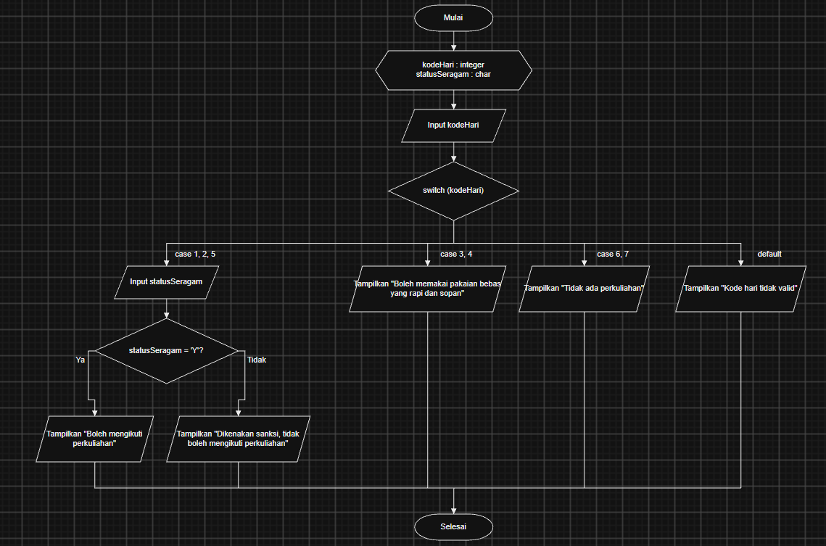

Soal 3 - Sistem Login Learning Management System (LMS) Kampus
